**Sprint 1 - Endurance Design Document**

November12**, 20**20

**Table of Contents**

**1.** **EXECUTIVE SUMMARY 3**

1.1 Project Overview 3

1.2 Purpose and Scope of this Specification 3

**2.** **PRODUCT/SERVICE DESCRIPTION 3**

2.1 Product Context 3

2.2 User Characteristics 3

2.3 Assumptions 3

2.4 Constraints 3

2.5 Dependencies 4

**3.** **REQUIREMENTS 4**

3.1 Functional Requirements 4

3.2 Security 4

*3.2.1* *Protection* 4

*3.2.2* *Authorization and Authentication* 4

3.3 Portability 4

**4.** **REQUIREMENTS CONFIRMATION/STAKEHOLDER SIGN-OFF** 5

**5.** **SYSTEM DESIGN** 5

5.1 Algorithm 5

5.2 System Flow 6

5.3 Software 6-8

5.4 Hardware 9

5.5 Test Plan 9

5.6 Task List/Gantt Chart 10

5.7 Staffing Plan 10

# Executive Summary

## ***Project Overview***

The project is designed to have a robot successfully complete a rectangular endurance course without colliding with any obstacles. The robot must also adhere to specific distance and turning requirements outlined in the requirements table.

## ***Purpose and Scope of this Specification***

This product and program runs within all legal requirements. No laws are broken in the utilization of this program and robot. All legal mandates are met. Outlines and meets all requirements present in this document.

# Product/Service Description

## ***Product Context***

This product is more effective than other products due to its simplicity within the code and ease of maneuverability. It interacts with Sphero EDU software, available on mobile devices as well as computers.

## ***User Characteristics***

Students and children will use this product to demonstrate a basic version of code that can teach them the ins and outs of coding and program design. This product could be utilized at a place like Code Ninjas, an early coding academy that teaches the basics of code to children. This software can teach the beginning elements of coding and algorithmic design to kids with or without a specific interest in the field. Little technical experience is required due to the lack of actual code needed to create a program. The block coding does not require the user to have previous computer science knowledge, making the market for this market larger than the competition.

## ***Assumptions***

It is assumed that the user has access to a device that can run the Sphero EDU program, a SPRK+, and enough common sense to understand and run the program.

## ***Constraints***

The constraints of this program are the limit of block code on the Sphero EDU app. The robot can do only as many things available on the app block coding software. Another constraint could be the strength of the bluetooth connection to the robot, limiting the range at which the robot can operate while away from the user. The only main constraint with the utilization of the program is that the user must have a SPRK+ robot as well as a bluetooth compatible device with the Sphero EDU software.

## ***Dependencies***

This program requires a SPRK+ Robot and the Sphero EDU app to successfully run the program.

# Requirements

* 1. ***Functional Requirements***

|  |  |  |  |
| --- | --- | --- | --- |
| **Req#** | **Requirement** | **Comments** | **Priority** |
| ENDUR_01 | Robot Must Say “Ready Set Go” and Light Up Green at the Start |  | 1 |
| ENDUR_02 | Robot Must Travel Straight from the Start for 22’ | Robot Must Not Collide w/Anything | 1 |
| ENDUR_03 | Robot Must Turn Right at the End of the 22’ | Turn in the Middle of the Yellow Square at the End of the Straight Piece | 1 |
| ENDUR_04 | Robot Must Travel Straight After Turning for 11’8” | Robot Must Not Collide w/Anything | 1 |
| ENDUR_05 | Robot Must Turn Right at the End of the 11’8” | Turn in the Middle of the Yellow Square at the End of the Straight Piece | 1 |
| ENDUR_06 | Robot Must Travel Straight After Turning for 21’6” | Robot Must Not Collide w/Anything | 1 |
| ENDUR_07 | Robot Must Turn Right at the End of the 21’6” | Turn in the Middle of the Yellow Square at the End of the Straight Piece | 1 |
| ENDUR_08 | Robot Must Travel Straight and Return to Its Starting Position After Turning for 11’11” | Robot Must Not Collide w/Anything | 1 |
| ENDUR_09 | Robot Must Stop | Stop in the Yellow Square Where it Started | 1 |
| ENDUR_10 | Robot Must Light Up Red and Say “I’m Done I Need Water” at the End |  | 1 |

## ***Security***

### **Protection**

This program does not have large security protection due to the lack of personal information in this program. There is nothing worth stealing within the program, therefore, highly maintained security is not necessary such as those present on a banking website. The activity of the robot is logged in sensor data but deleted after the program is run again. Data integrity checks are not necessary with this program due to the lack of personal information present.

### **Authorization and Authentication**

A user must authorize their identity by the logging into their Sphero EDU account in order to access their program. Programs can be made public or private depending on the preferences of the user.

## ***Portability***

This program is portable due to the portability of the physical robot as well as the code can be run from any device with bluetooth and the Sphero EDU software.

# Requirements Confirmation/Stakeholder sign-off

|  |  |  |
| --- | --- | --- |
| **Meeting Date** | **Attendees (name and role)** | **Comments** |
| 11/05/20 | Andrew Catapano, Estania Blanc, & Matthew Emery | Confirmed all Requirements listed in Gantt Chart and Algorithm |

# System Design

## ***Algorithm***

* Start Program
* Robot says “Ready Set Go”
* Robot lights up Green
* Robot begins moving straight and continues so for 22’
* Turn 90 degrees right in yellow square at the end of the 22’
* Robot begins moving straight and continues so for 11’ 8”
* Turn 90 degrees right in yellow square at the end of the 11’ 8”
* Robot begins moving straight and continues so for 21’ 6”
* Turn 90 degrees right in yellow square at the end of the 21’ 6”
* Robot begins moving straight and continues so for 11’ 11”
* Robot stops in the yellow square at the end of 11’ 6”
* Robot lights up red
* Robot says “I’m Done I Need Water”
* End Program

## ***System Flow***

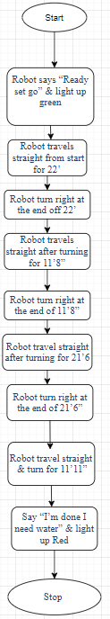

## 

## Software

The software for this program was developed in the Sphero EDU coding platform using block code. It is required for the program required successfully.

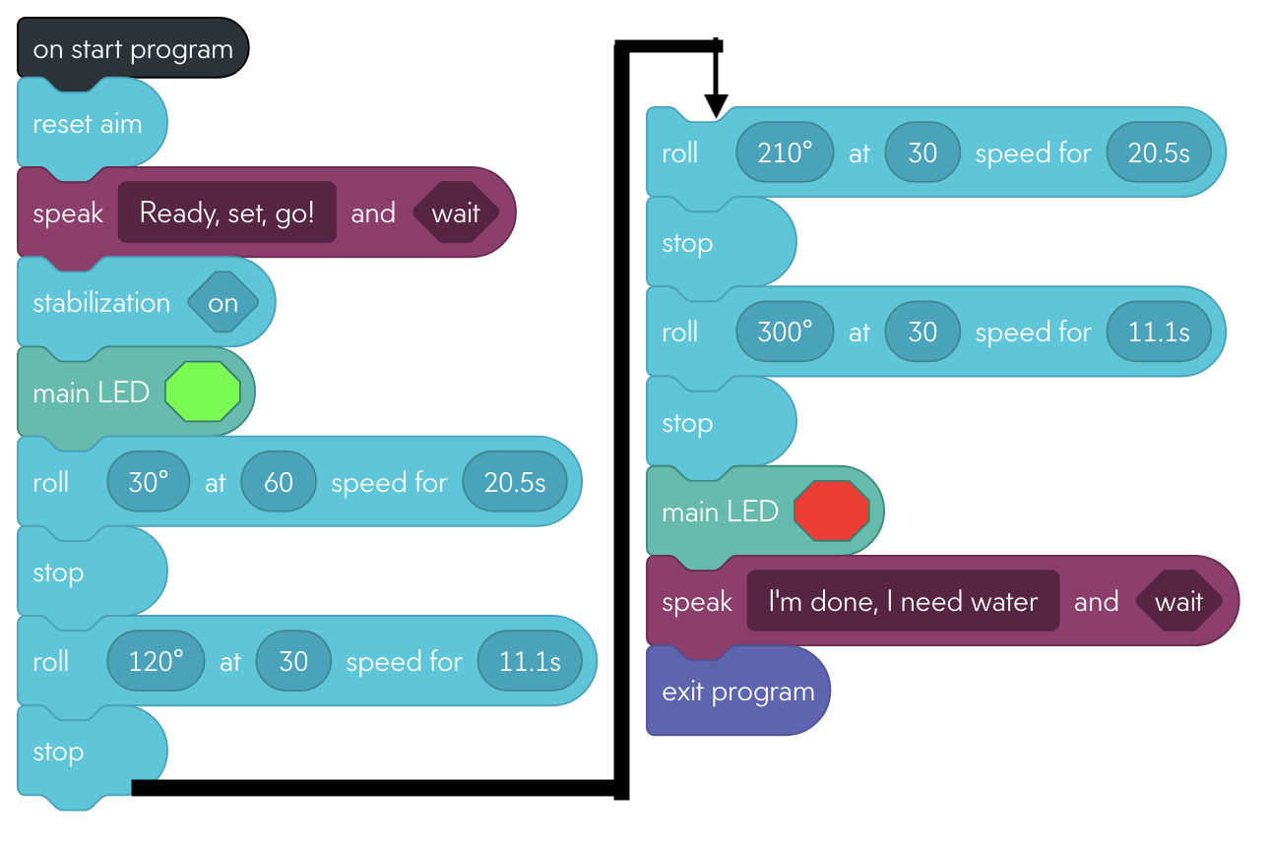

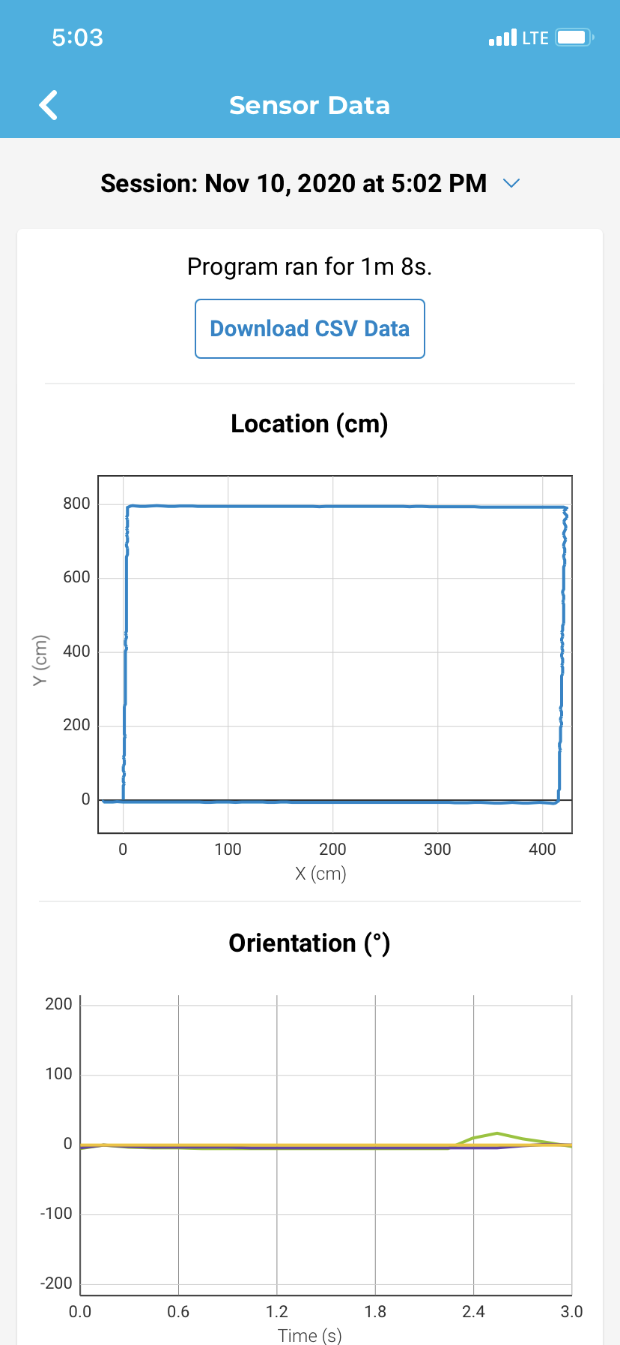

## ***Hardware***

The hardware for this program includes the SPRK+ Robot, computers and phones used to create and test code, as well as the course in the classroom at Monmouth University.

## ***Test Plan***

|  |  |  |  |  |  |
| --- | --- | --- | --- | --- | --- |
| **Reason for Test Case** | **Test Date** | **Expected Output** | **Observed Output** | **Staff Name** | **Pass/Fail** |
| To confirm first step in alorightm | 11/10 | Turn green and say “Ready, Set, Go” | Robot Turned Green and said “Ready, Set, Go” | All Members | Pass |
| To confirm second step in alorightm | 11/10 | Robot Travels Straight for 22’ | Robot travelled too short of a distance | All Members | Fail |
| To confirm third step in alorightm | 11/10 | Robot turns right and travels straight for 11’ 8” | Robot turned successfully but travelled too short of a distance | All Members | Fail |
| To confirm fourth step in alorightm | 11/10 | Robot turns right and travels straight for 21’ 6” | Robot turned successfully but travelled too short of a distance | All Members | Fail |
| To confirm fifth step in alorightm | 11/10 | Robot turns right and travels straight for 11’ 11” | Robot turned red but travelled too short of a distance | All Members | Fail |
| To confirm sixth step in alorightm | 11/10 | Robot Stops and says “I’m done I need water” | Robot stopped and said, “I’m done I need water” | All Members | Pass |
| To retest second step in alorightm | 11/10 | Robot Travels Straight for 22’ | Robot travelled the desired distance but varied slightly due to the floor | All Members | Pass |
| To retest third step in alorightm | 11/10 | Robot turns right and travels straight for 11’ 8” | Robot turned successfully and travelled the desired distance but varied slightly due to the floor | All Members | Pass |
| To retest fourth step in alorightm | 11/10 | Robot turns right and travels straight for 21’ 6” | Robot turned successfully and travelled the desired distance but varied slightly due to the floor | All Members | Pass |
| To retest fifth step in alorightm | 11/10 | Robot turns right and travels straight for 11’ 11” | Robot turned successfully and travelled the desired distance but varied slightly due to the floor | All Members | Pass |

## ***Task List/Gantt Chart***

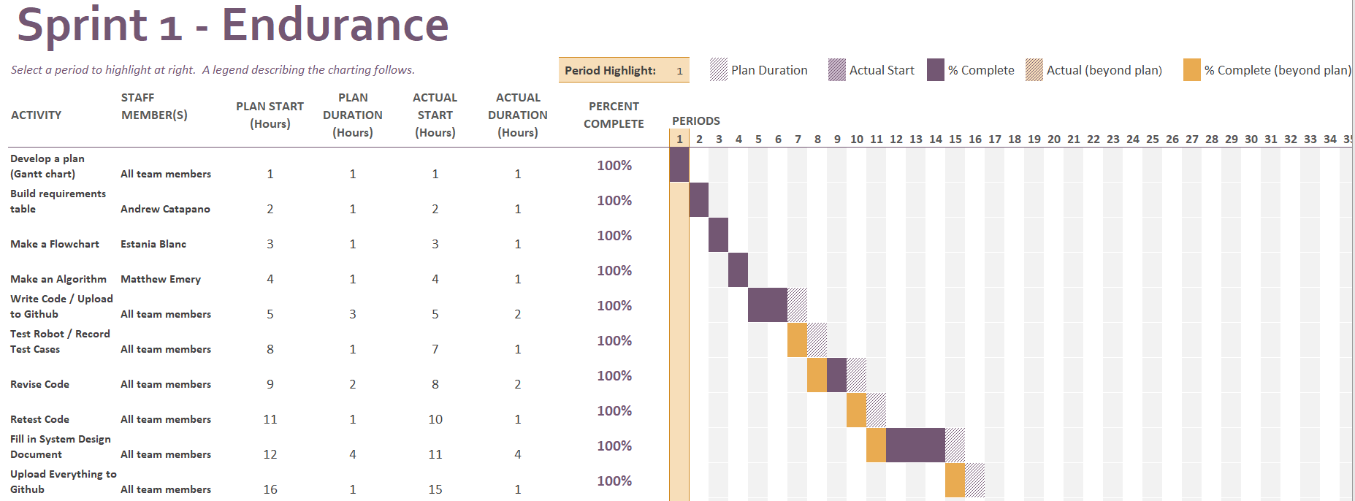

## ***Staffing Plan***

|  |  |  |  |
| --- | --- | --- | --- |
| Name | Role | Responsibility | Reports To |
| Matthew Emery | Programmer/Testers/Documenters/Technical Writer | * Algorithm * Test/Build Code * Complete SDD * Collaborate with other members | All Team Members |
| Andrew Catapano | Project Manager/ Programmer/Testers/Documenters/Technical Writer | * Requirements * Test/Build Code * Complete SDD * Collaborate with other members | All Team Members |
| Estania Blanc Doblas | Programmer/Testers/Documenters/Technical Writer | * Flow Chart * Test/Build Code * Complete SDD * Collaborate with other members | All Team Members |